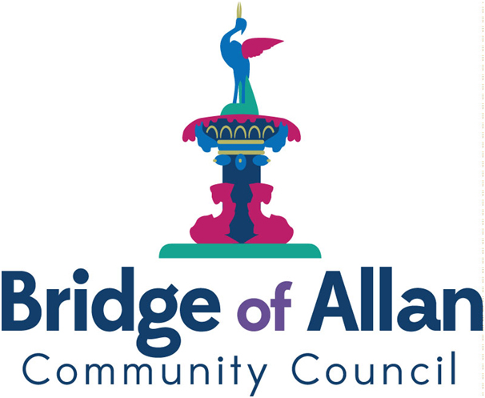

Bridge of Allan Community Council

Agenda

17th January 2023

1930 hours : the Allan Centre GP Room

1. Welcome, Apologies and Conflict of Interest

2. Approval of Minutes, Matters Arising and Action Log

3. Police Report Duty Officers

4. Christmas Lights Alasdair Taylor
Emma Fradgley

5. Post Office Closure Mike Watson

6. CAP Review Heather Jones

7. LPP Mike Watson

8. Guala UCP Site Mike Watson

9. Haws Park Robin Kleinman

10. The Larder Cllr. Dodds

11. Planning Report Alastair Heron

12. Chair’s Report Mike Watson

13. Secretary’s Report Leslie Harkness

14. Treasurer’s Report Alasdair Taylor

15. Residents’ Voice

16. AOCB

17. Date of Next Meeting

