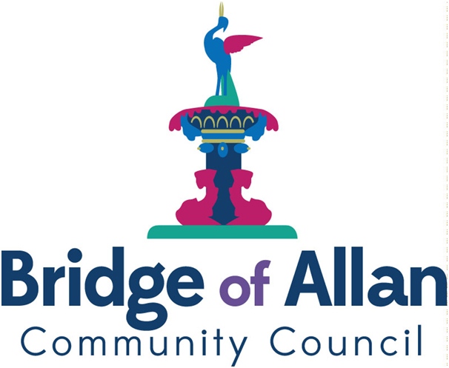

Bridge of Allan Community Council

Agenda

17th November, 2020

1930 hrs, Virtual Online Meeting via Zoom*

1. Welcome, Apologies and Conflict of Interest

2. Approval of Minutes, Matters Arising and Action Log

3. Police Report Duty Officer (s)

4. Speeding Issues Update Alasdair Taylor

5. Tennis Courts Bill Fortune

6. Wallace Monument Stakeholder Group Update Janie Meikle Bland

7. Play Park Initiative Siobhan Hencher

8. Blairforkie Drive Development Iain McCusker

9. Christmas Lights Anna Doeser
Siobhan Hencher

11. CityFibre Update Cllr. Tollemache

12. Communications Role Mike Watson

13. Planning Report Iain McCusker

14. Chair’s Report Mike Watson

15. Secretary’s Report Leslie Harkness

16. Treasurer’s Report Anna Doeser

17. Residents’ Voice

16. AOCB

18. Date of Next Meeting

*Website: zoom.us

Meeting ID: 784 615 6009

Password: 832459

